Courier Companies Investigation

Royal Mail
URL: https://www.royalmail.com
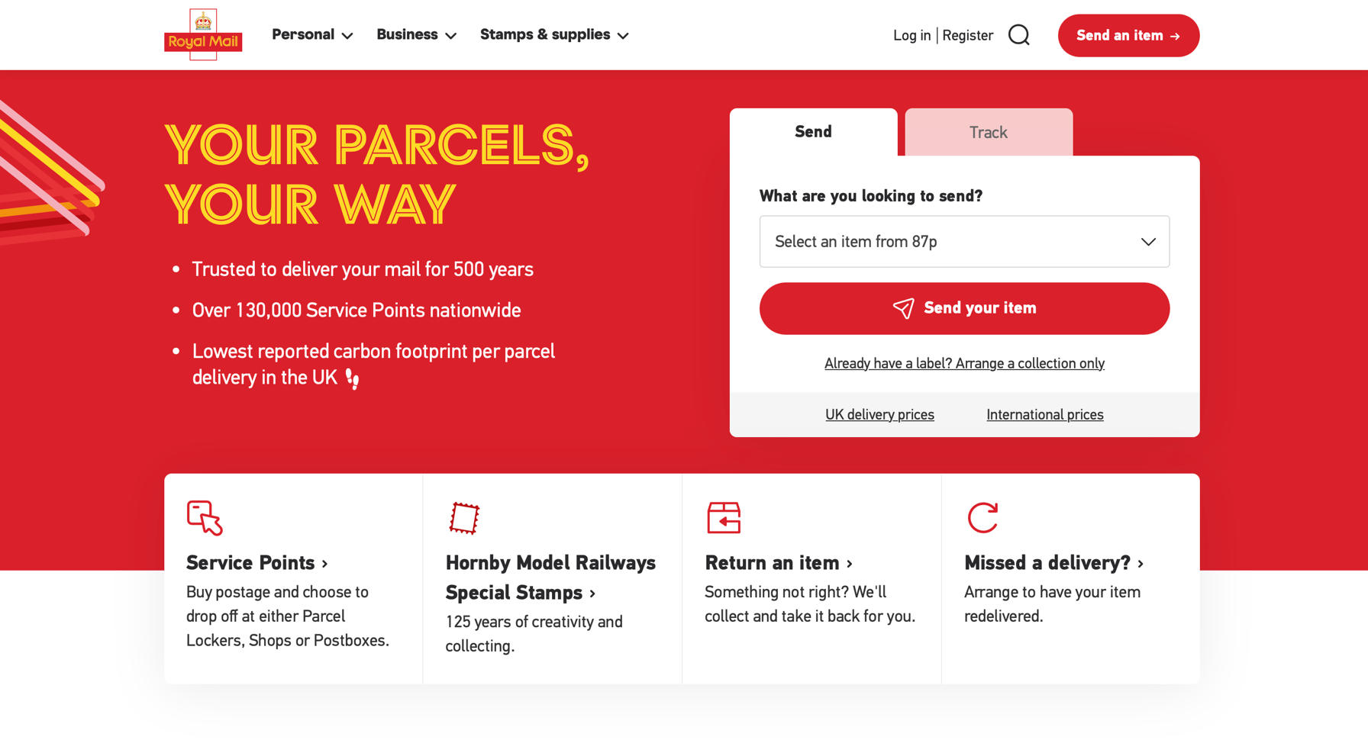
Figure 1 : Royal Mail Home Page

Royal Mail’s website primarily targets individual customers, offering parcel sending and tracking as its core services. Upon arrival, users are presented with clear options for sending items or tracking existing deliveries, supported by visible pricing tiers based on parcel size and weight. Navigation is handled through a standard top menu with large dropdown sections, although the ordering process is spread across multiple pages, including destination, service selection, sender and recipient details, and payment.

Parcel tracking is available without requiring login and is accessed using a reference number. While full tracking details were not observed without completing an order, the system appears designed to provide status updates and location history. Account registration supports both personal and business users, with optional email and SMS notifications, indicating integrated communication channels.

Figure 2 shows that the cheapest delivery options are placed within a dropdown list, making them less immediately visible. This design may influence users toward selecting higher-priced services. It also demonstrates steps of completing the order and ability to move between them.
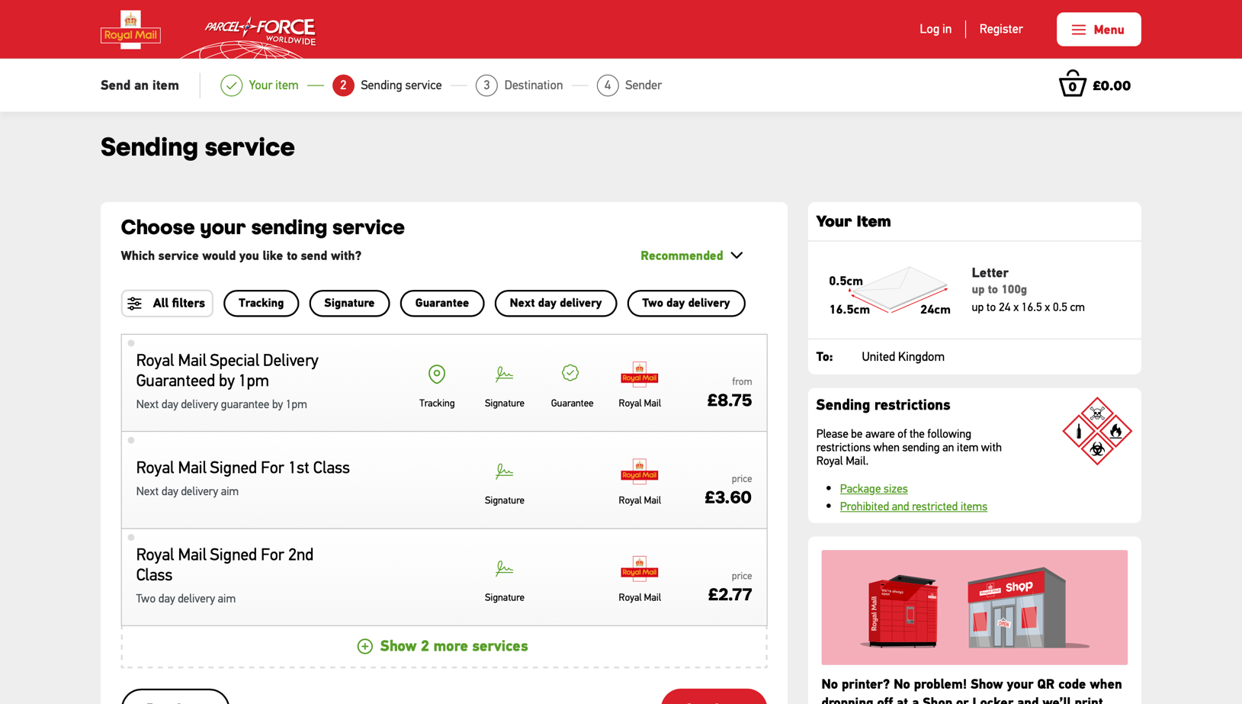
Figure 2: Sending Page

Payment is handled directly on the website using credit or debit cards, PayPal, and Apple Pay, without redirecting users to an external platform. The visual design is consistent, using a limited colour palette and clear spacing, and the site provides extensive support resources.

However, the interface contains a large amount of secondary content and promotional material, which can distract from the ordering process. The multi-page flow also makes sending parcels feel longer than necessary. Despite this, Royal Mail stands out for its professional presentation, trusted brand identity, and structured service options. Elements such as reference-based tracking, integrated payments, and clean layout principles will inform the design of my own parcel management system.

Evri
URL: https://www.evri.com
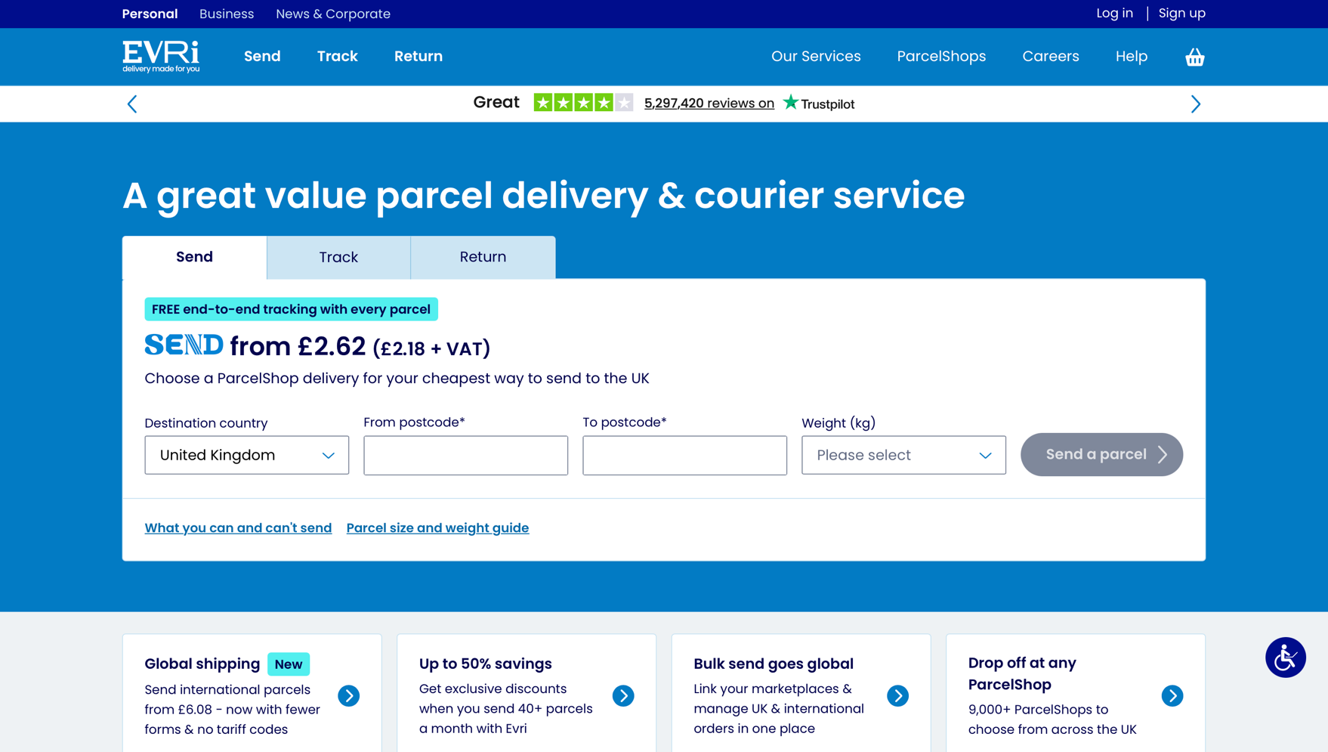
Figure 3: EVRI Home Page

Evri’s website presents a clear task-oriented layout, with prominent options for sending, tracking, and returning parcels directly on the homepage. Tracking is available without login using either a 16-digit parcel number or an 8-digit calling card number, while sending a parcel begins with a simple form requesting destination postcodes and parcel weight, with prices displayed immediately.

Figure 3 contains a Send/Track/Return section that I would be happy to incorporate in my app due to its high functionality and friendly user interface.

Navigation is straightforward, with fewer menu options than Royal Mail, which makes the interface feel less overwhelming. The parcel ordering process is largely contained within a single progressive page, where new steps appear as previous selections are completed. This approach feels more efficient than Royal Mail’s multi-page flow. Payment is integrated directly into the website and supports card and PayPal.
However, the visual design feels less polished, with small fonts, large unused page margins, and a colour palette that reduces readability. Although email and phone number fields are presented as optional, the system does not allow users to proceed without completing them, which may confuse users. Account login is also required to finalise purchases, limiting true guest usage.

Figure 4 shows completion tracking similar to Royal Mail’s. Only after selecting the current option (e.g. “Delivery Speed”) does the next section (e.g. “Drop off or collection”) appear.
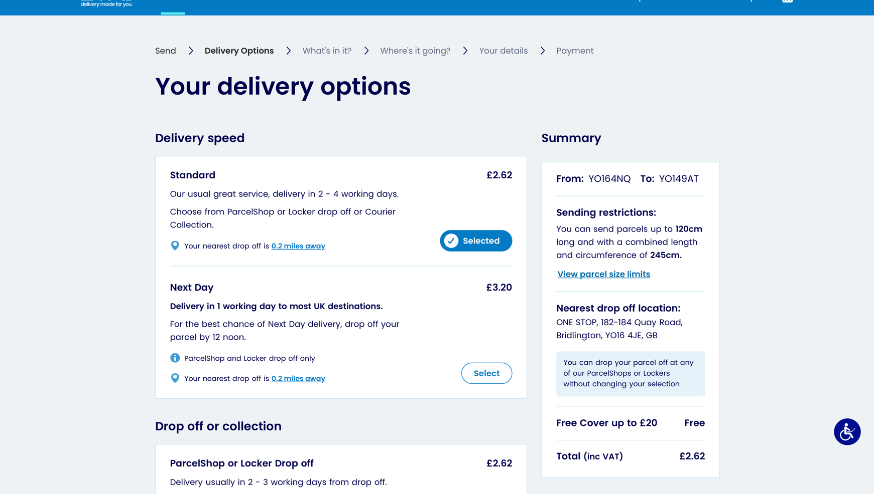
Figure 4: EVRI Sending Page

Evri’s main strength lies in its simplified ordering flow and clear front-page functionality. While the interface lacks refinement, the streamlined send-and-track design provides useful inspiration for reducing complexity in my own parcel management system.

DPD
URL: https://send.dpd.co.uk
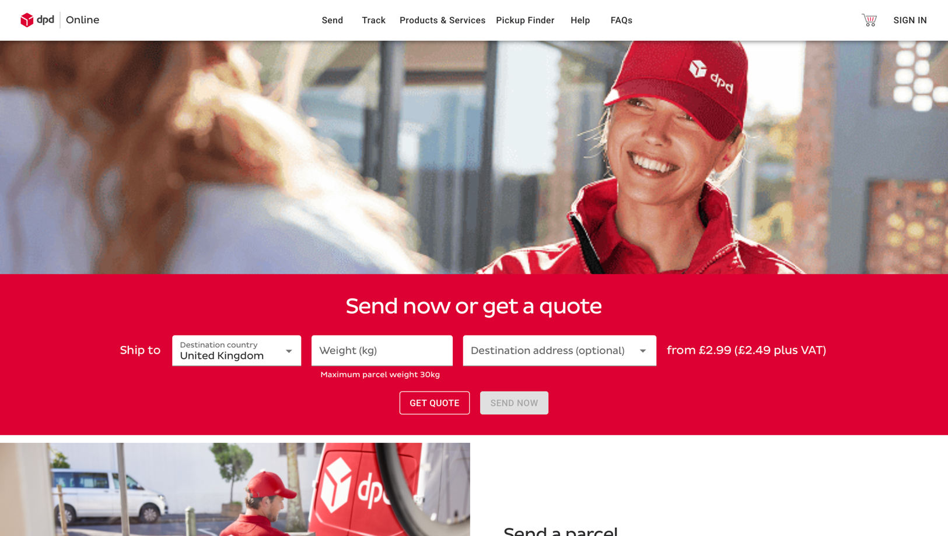
Figure 5: DPD Home Page

DPD’s parcel sending system is accessed through a separate site (send.dpd.co.uk), which offers a structured step-by-step workflow for booking deliveries. Users are guided through parcel details, delivery options, and payment using a clear progress bar. Unlike Royal Mail and Evri, DPD requires manual input of parcel dimensions and declared value, which may be inconvenient for users without measuring tools. Collection and delivery options are presented clearly, though many features incur additional costs.
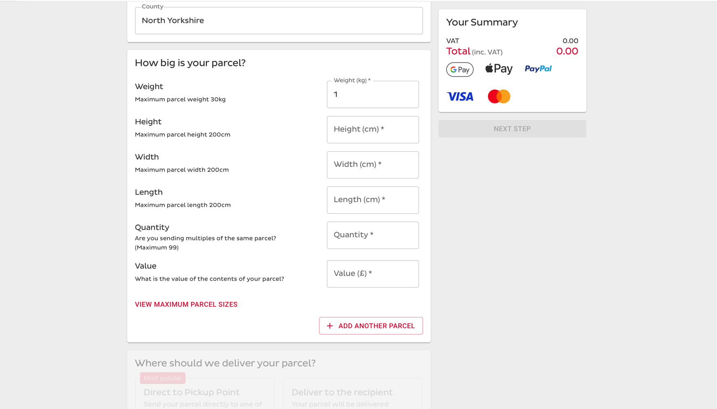
Figure 6: DPD Sending Page

The interface is visually clean with a consistent colour palette and strong payment support including card, PayPal, Apple Pay, and Google Pay. Payment is handled via an embedded checkout overlay, providing a smooth experience. Guest checkout is supported without mandatory account creation.

Tracking requires a parcel number and postcode, and DPD provides detailed delivery history with timestamps and locations. Based on recent personal usage, SMS notifications are sent for key events such as delivery scheduling, delivery attempts, redirections, and successful delivery, with links to a lightweight tracking page that allows delivery changes.

However, navigation between marketing pages and functional booking pages is inconsistent, and mobile usability is poor. DPD’s strength lies in its detailed tracking and flexible delivery management, though the ordering process is more complex than competitors.

Investigation Summary
Overall, each courier website demonstrated different strengths and weaknesses in terms of usability, ordering flow, and tracking functionality. Royal Mail provides a professional and trustworthy interface with clear service tiers, integrated payments, and reference-based tracking, but the ordering process is fragmented across multiple pages and surrounded by large amounts of secondary content, which can distract users from the main task.

Evri offers the most direct homepage experience, with Send, Track, and Return actions immediately visible. Its progressive single-page ordering flow feels faster and less overwhelming than Royal Mail’s approach. However, visual design issues such as small fonts, large unused margins, and unclear form validation reduce usability and polish.

DPD provides the most detailed tracking experience, including full delivery history with timestamps and locations, as well as SMS notifications for key events and delivery changes. Its payment system supports a wide range of methods and uses a clear step indicator during checkout. However, the requirement to manually enter parcel dimensions and the separation between marketing and booking pages increase complexity.

From this investigation, I identified several features to carry forward into my own project: a task-focused homepage similar to Evri, detailed parcel tracking and SMS updates inspired by DPD, and Royal Mail’s structured service presentation and integrated payment flow. At the same time, I aim to avoid excessive page fragmentation, unnecessary form fields, and visually cluttered layouts. The goal is to combine clarity, simplicity, and meaningful tracking while keeping the user journey concise and focused.

These findings directly inform the functional and visual requirements of my proposed parcel management system.

Design Implications and Features to be Incorporated
The comparative investigation of Royal Mail, Evri, and DPD has directly informed the design decisions for this project. Rather than replicating any single system, selected strengths from each platform will be incorporated while avoiding observed usability issues.

From Royal Mail, the project will adopt a structured and professional layout with clear spacing, consistent colour usage, and strong readability. The system will also implement an accessible account registration process, allowing users to create an account in one streamlined flow rather than distributing registration steps across multiple pages. Reference-based parcel tracking without mandatory login will also be incorporated, ensuring accessibility for guest users.

From Evri, the project will adopt a task-focused homepage design, where core actions such as “Send Parcel” and “Track Parcel” are immediately visible. Additionally, a progressive form approach will be implemented, where subsequent sections of the order form only become active once previous selections are completed. This reduces cognitive overload and simplifies the user journey.

From DPD, the project will incorporate detailed tracking information including parcel status history with timestamps. SMS notifications will be implemented for key delivery events, such as dispatch and delivery confirmation, while avoiding excessive messaging. The use of a clear step indicator during the checkout process will also be adopted to improve transparency in multi-stage interactions.

At the same time, the system will intentionally avoid multi-page fragmentation, excessive promotional content, unnecessary form requirements, and complex manual parcel dimension inputs. The overall objective is to combine clarity, simplicity, and informative tracking within a streamlined and user-focused parcel management platform.

